
NAAN MUDHALVAN ARTS INTERNSHIP PROGRAM 2026
Frontend Wen Development using React
STUDENT NAME :RAHAMATH NISHA M
YEAR :III
COLLEGE CODE :bru12
DEPARTMENT :BCA
ROLL NO :2422J0258
NMID :DBD2284737D7BEAA0F041822F34B7F58
DATE :17-06-2026
TITLE : JOB PORTAL WITH SEARCH AND FILTERS
GITHUB LINK : https://github.com/rahamathnisha063-glitch/Naan- mudhalvan-internship-project.git

1. ABSTRACT
The Job Listing Application is a web-based application developed using ReactJS. The main objective of this project is to help users view and manage job opportunities in an organized manner. Users can browse available job listings, save jobs they are interested in, and remove saved jobs when required. The application provides a simple and interactive interface that improves the user experience. By using ReactJS, the application updates information dynamically without reloading the page. This project demonstrates the use of modern web development technologies and React concepts to build an efficient job management system.
2. PROBLEM STATEMENT
Many job seekers find it difficult to keep track of multiple job opportunities available on different platforms. Important job listings may be forgotten or lost while browsing. There is a need for a simple and user-friendly application that allows users to view job listings and save preferred jobs for future reference. This project aims to solve this problem by providing a platform where users can easily organize and manage job opportunities in one place.
3.Objectives:
The main objective of the job listing application is to provide a simple platform for users to viw and manage job oppurtinities efficiently. The application allows the user to browse available jobs, save preffered job listing, and remove saved jobs when needed. It also aims to provide a user-friendly interface while demonstrating the use of ReactJS concepts such as components, state management,props,and event handling.
4. PROJECT SCOPE
The Job Listing Application allows users to view available job opportunities and save selected jobs for future reference. Users can add jobs to the saved jobs section and remove them whenever required. The application provides a responsive and interactive interface with real-time updates. The current scope is limited to frontend functionality and does not include user authentication, database storage, job applications, or company management features. Future improvements may include job search, filtering, user accounts, and backend integration.
5. TECHNOLOGIES USED
HTML: Used to create the structure and layout of the application.
CSS: Used to design and style the user interface, including job cards, buttons, and sections.
JavaScript: Used to handle user interactions, application logic, and dynamic functionality.
ReactJS: Used to create reusable components, manage state, and provide a responsive user experience.
6. APPLICATION FLOW
The user opens the Job Listing Application.
The system displays a list of available job opportunities.
Each job card contains details such as job title, company name, location, and salary package.
The user browses the available job listings.
When the user clicks the "Save" button, the selected job is added to the Saved Jobs section.
The Saved Jobs section displays all jobs selected by the user.
The user can remove any saved job by clicking the "Remove" button.
The application updates the displayed information instantly without refreshing the page.
The user can continue managing saved jobs as needed.
7. KEY REACT CONCEPTS USED
Components
The application is divided into reusable components such as Job List, Job Card, and Saved Jobs section, making the code easier to manage and maintain.
State Management
React state is used to store job data and saved jobs. Whenever the state changes, the interface updates automatically.
Props
Props are used to transfer data and functions between components, enabling communication within the application.
Event Handling
Event handling is used to perform actions such as saving jobs and removing jobs when users click buttons.
Conditional Rendering
Conditional rendering is used to display content based on user actions and application state.
List Rendering
The map() function is used to display multiple job listings dynamically from an array of job data.
8. EXPECTED OUTPUT
The application displays available job opportunities in a structured format. Users can browse job listings and save preferred jobs. Saved jobs are displayed in a separate section where users can manage them easily. The interface updates dynamically whenever a job is saved or removed, providing a smooth and interactive user experience.
Output:
Display job listings.
Save selected jobs.
View saved jobs.
Remove saved jobs.
Dynamic updates without page refresh.
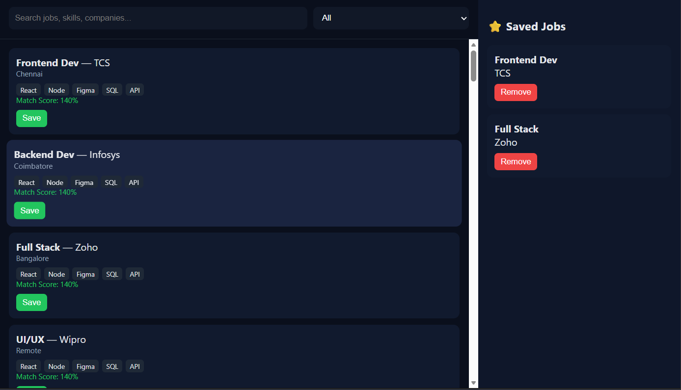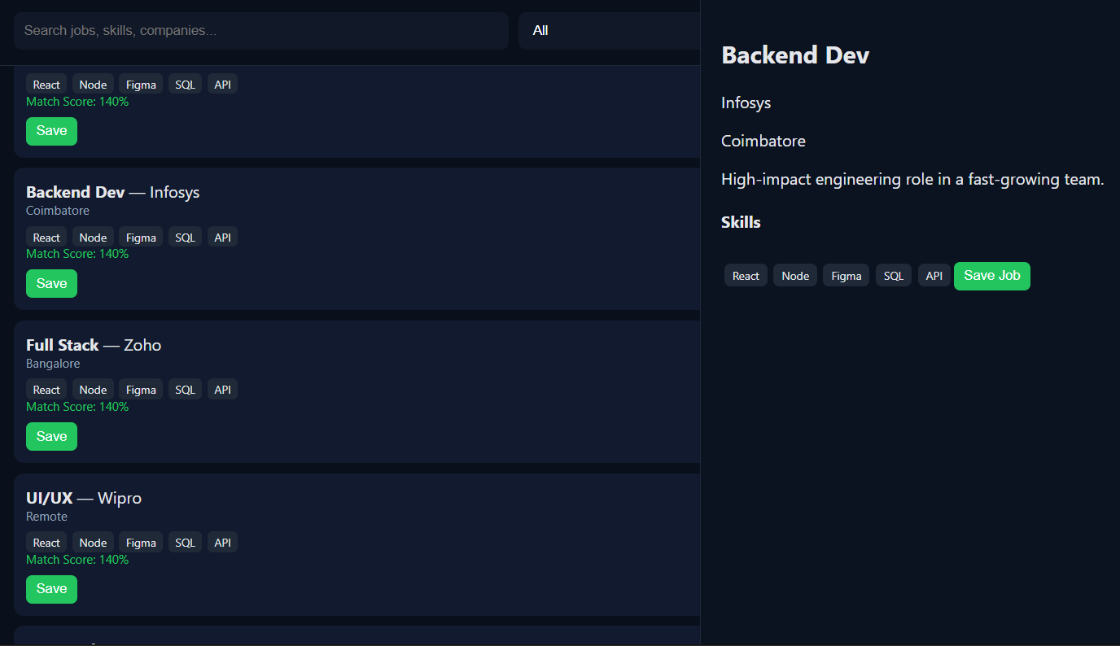
9. CHALLENGES FACED
One of the main challenges was managing the saved jobs list dynamically. Ensuring that the user interface updated correctly whenever a job was saved or removed required proper state management. Another challenge was maintaining communication between components using props. Designing a clean and responsive user interface also required careful styling. These challenges were resolved by using React state management, proper component structure, and effective CSS design techniques.
10. LEARNING OUTCOMES
Through this project, knowledge of ReactJS and frontend web development was improved. The project provided practical experience in creating reusable components, managing application state, handling events, and passing data using props. Skills in HTML, CSS, JavaScript, debugging, and user interface design were also enhanced. The project helped in understanding how modern web applications are developed using ReactJS.
11. CONCLUSION
The Job Listing Application was successfully developed using HTML, CSS, JavaScript, and ReactJS. The application provides an efficient way for users to view, save, and manage job opportunities. The project successfully addressed the problem of organizing job listings and demonstrated the practical use of React concepts such as components, state management, props, and event handling. Overall, the project achieved its objectives and provided valuable learning experience in frontend web development.

